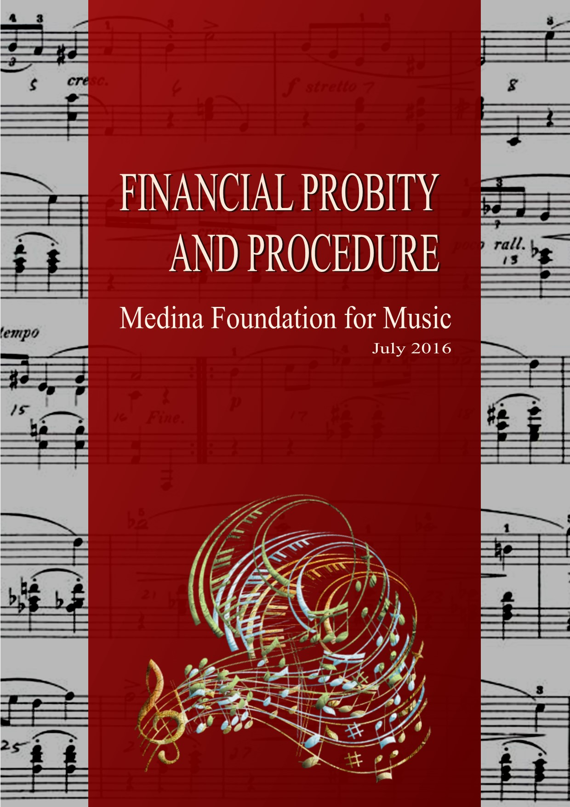

Medina Foundation for Music
Financial Probity and Procedure

Published by the Medina Foundation for Music
Contributions:
Mark Agius

Acknowledgements:
Jahel Sammut
Joseph Schembri
Ninette Sammut
National Commission for Further and Higher Education

Setting and Design:
Mark Agius

Review and Editing:
Karen Darmenia

Table Of Contents Page

1. Introduction 173 2. The Expected Standards of Probity 173
3. Combating Fraud 174
4. Financial Probity and Procedures 175

Appendix 178
References 179

1
Preamble

The Foundation will be following the financial management procedures through the procedures outlined in this document which clearly states the organization’s expectations for transparency and accountability for all finance related functions.

- The Financial Responsibility of the Medina Foundation of Music, hereafter MFM, is governed by its Statute in accordance with the requirements of the Office of the Commissioner for Voluntary Organisations as stipulated in the Voluntary Organisations Act 2007.

- The foundation is a non-profit organization whereby its revenue will be re-invested in the foundation itself.

- For the purpose of this Policy, persons serving within the Medina Foundation for Music in a representative capacity shall be referred to as its members.

- Administrators and members of the MFM must act in accordance with this Policy. By complying with the Policy administrators and members are protecting themselves from any false accusation of malpractice, corruption or bias.

- The foundation will follow a yearly plan/forecast including revenue from local and Eu funds, sponsors, fundraising, sales of workbooks, performance examination books and past papers.

2
The Expected Standards of Probity

- All administrators and members must act honestly, impartially, in good faith and with integrity at all times and in accordance with the Foundation’s Code of Probity (Appendix).

- All those with responsibility for the resources held by the Medina Foundation for Music must take all reasonable steps to safeguard them.

- All members must act with propriety in the use of resources and the handling and use of the Foundation’s funds.

- All prescribed financial procedures designed to reduce the possible risk of malpractice must be applied strictly and impartially at all times.

- All members have a responsibility to act in good time to prevent or report fraud, bribery or corruption and to co-operate fully with any internal checks or reviews or fraud investigations.

- Members should report any financial malpractice or suspected malpractice in good faith.

- All administrators and members must both exercise common sense before accepting gifts or hospitality from outside individuals or organisations to ensure their incolumity.

3
Combatting Fraud

- For the purpose of this Policy, the definition of Fraud includes but is not restricted to:

- Theft - Dishonestly appropriating the property of another with the intention of permanently depriving them of it including the removal or misuse of funds, assets or cash.
- False Accounting - Dishonestly destroying, defacing, concealing or falsifying any account, record or document required for any accounting purpose, with a view to personal gain for another or with intent to cause loss to another or furnishing information which is or may be misleading, false or deceptive
- Bribery and Corruption - The offering, giving, soliciting or acceptance of an inducement or reward that may influence the actions taken by the authority, its members or officers
- Deception - Obtaining property or pecuniary advantage by deception and obtaining services or evading liability by deception
- Collusion - The term "collusion" in the context of the reporting of fraud is used to cover any case in which someone incites, instigates, aids and abets or attempts to commit any of the crimes listed above.

- The prevention of fraud is to be understood as both a corporate and an individual imperative.

- All administrators and members should be alert to the possibility that unusual events or transactions could be indicators of fraud.

- All administrators and members have a duty to co-operate fully with whoever is conducting internal checks or reviews or fraud investigations.

- Administrators will ensure that an adequate system of internal controls exists within their areas of responsibility and that the controls operate effectively.

4
Financial Probity and Procedures

Having a written financial procedure manual is critical to good risk management as it ensures the organization to operate its institutionalized finances even if a new accounts administrator/treasurer is appointed. The following procedures will therefore be in place:

- Accounting records

- The Treasurer will keep such accounting records and will be responsible for the preparation of such documents as will enable the compilation of Annual Report and Tax Return.

- A certified accountant or auditor with adequate knowledge of non-profit finance and accounting practices will oversee the compilation of Annual Report and Tax Return.

- The Foundation’s balance sheet with a profit and loss account will be closed at the end of each month including a review of each month’s transactions.
- Each bank, asset, liability, and restricted account will be reconciled to statements from external institutions, such as banks, or internal schedules or lists, such as a list of what is owed to the organization, a list of payables and a list of restricted grants.

- An audit folder will be kept and updated monthly with the necessary copies of bank statements, schedules, financial statements and other documentation. Hence, income and expense will be kept aligned with the planned budget whereby, financial reports, accounting structure, and budget should all match in format.

- Information on internal processing forms the will be coded and arranged in such a way as to facilitate entry of transactions in accounting software, including a place for an approval signatures which will be required for approval before processing any financial transactions.

- The annual accounts will be subject to independent examination or other scrutiny in accordance with relevant legislation.

- Documents and records will be stored securely and copies archived at the principal’s office.

- Using excel for security purposes, documents will be saved on the cloud in the Foundation’s Office 365 tenant.

- Financial records held electronically will be protected by the creation of copies at appropriate intervals.

- An accurate and up to date record of fixed assets will be maintained and an audit of fixed assets will be carried out annually.

- Where and if applicable, subscriptions will be levied each year and membership records will be maintained accurately.

- Receipts

- Proper control will be kept over the issue of tickets for concerts and other events.

- All receipts, whether cash or cheque, will be banked at the earliest reasonable opportunity.

- The Treasurer will exercise the greatest control over the counting of cash receipts as circumstances allow.

- Cash receipts may be used to fund reimbursement of expenses subject to 6.3.4.below. Otherwise cash receipts will only be used to fund cash payments in exceptional circumstances agreed in advance by the CEO and Treasurer.

- Payments

- Up to three members of the Board of Administrators and not less than two, one of whom shall be the CEO, will be signatories to the bank account(s), and those signatories will be required to authorise payments, whether electronically, by cheque, or by any other means.

- The Treasurer will hold any debit cards issued in respect of the bank account(s) and will use those cards only after agreement with the CEO, for each transaction.

- Wherever possible, payments will not be made in cash

- Payments will be supported by invoices or other documentation so far as possible

- Payments will be made as promptly as possible.

- Administrators with access to the online banking facilities will ensure that their PCs are secure and up to date with anti-virus, spyware and firewall software.

- Authorisation and Reporting

- A financial report will be presented by the Treasurer to each meeting of the Board of Administrators, showing the financial transactions which have been made since the last such report.

- The Board of Administrators will review the report and approve the transactions.

- Decisions taken by the Board of Administrators at their meetings or by email will be considered sufficient authority for the Treasurer to instigate financial transactions to carry them out, subject to the payments procedures above.

Appendix

Code of Probity
The MFM’s Code of Probity is adapted from The Seven Principles of Public Life as set out by Lord Michael Patrick Nolan in 1995. They are part of the Government of the United Kingdom’s policy for accountability and transperancy and are included in the Ministerial Code. The‘Nolan Principles', which are the basis of the ethical standards expected of public office holders, apply to anyone who works as a public office-holder. This includes people who are elected or appointed to public office, nationally and locally, and all people appointed to work in the civil service, local government, the police, the courts and probation services, non-departmental public bodies, health, education, social and careservices. The principles also apply to all those in other sectors that deliver public services.

Selflessness: Administrators and members of the Foundation should take decisions solely in terms of the Foundation’s interest when acting in its regards. They should not do so in order to gain financial or other material benefits for themselves, their family or their friends.

Integrity: Administrators and members of the Foundation should not place themselves under any financial or other obligation to outside individuals or organisations that might influence them in the performance of their work.

Objectivity: In carrying out business on behalf of the Foundation, including making appointments, awarding contracts or recommending individuals for rewards and benefits, administrators of the Foundation should make choices on merit.

Accountability: Administrators and members of the Foundation are accountable for their decisions and actions and must submit themselves to whatever scrutiny may be appropriate.

Openness: Administrators of the Foundation should be as open as possible about all the decisions and actions that they take. They should give reasons for their decisions and restrict information only when confidentiality clearly demands.

Honesty: Administrators and members of the Foundation have a duty to declare any personal interests relating to their duties within the Foundation and to take steps to resolve any conflicts arising in a way that protects the Foundation’s interest.

Leadership: Administrators of the Foundation should promote and support these principles by leadership and example.

References

Manchester Youth Band - Financial Probity Policy
http://www.mybb.org.uk/wp-content/uploads/2011/11/FinancialProbityPolicy-Nov2016.pdf

THOMAS MILLS HIGH SCHOOL FINANCIAL PROBITY - The School’s Code of Standards and Practice,
Thomas Mills High School, UK
http://www.thomasmills.suffolk.sch.uk/files/28%20-%20Financial%20Probity.pdf

HAYWOOD ACADEMY – Financial Probity
http://www.haywoodacademy.coop/governance/financial-probity/

EALING GRID for LEARNING – School Finance Handbook
https://www.egfl.org.uk/sites/default/files/Finance_data/Financial_Guidance/School_finance_handbook/2016-17%20Schools%20finance%20handbook.pdf

PROTECTION OF THE WHISTLEBLOWER ACT, 2013
http://www.justiceservices.gov.mt/DownloadDocument.aspx?app=lp&itemid=25151&l=1

CRIMINAL CODE (Malta) CHAPTER 9
http://www.justiceservices.gov.mt/DownloadDocument.aspx?app=lom&itemid=8574

The Seven Principles of Public Life from the Report of the Committee for Standards in Public Life (The Nolan Report) – University of Leicester, UK

http://www2.le.ac.uk/offices/finance/information-for-staff/governance-regulations/copy_of_regulations/appendices/appendix-a-the-seven-principles-of-public-life-from-the-report-of-the-committee-for-standards-in-public-life-the-nolan-report

