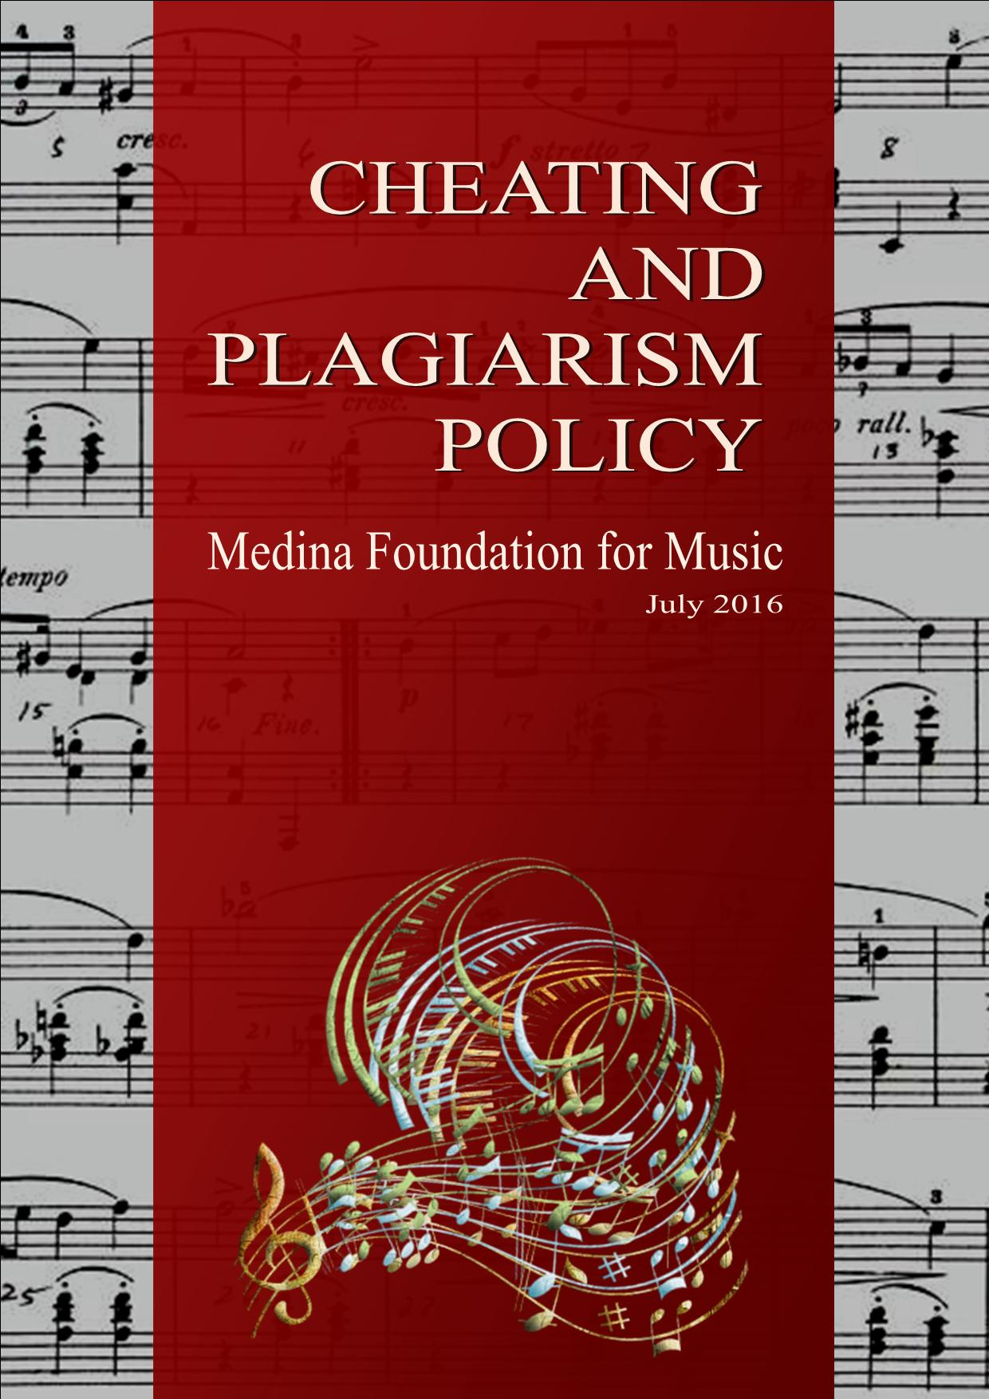

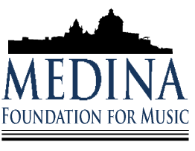

Medina Foundation for Music
Cheating and Plagiarism
Policy and Procedure

Published by the Medina Foundation for Music
Contributions:
Mark Agius

Acknowledgements:
Jahel Sammut
Joseph Schembri
Ninette Sammut
National Commission for Further and Higher Education

Setting and Design:
Mark Agius

Review and Editing:
Karen Darmenia

Table of Contents Page
- Preamble 119
- Policy 119
- Definition of Cheating 119
- Definition of Plagiarism 121
- Academic Action 121
- Cheating during an exam. 121
- Plagiarism in assessment by theses or composition 122
References 123

1
Preamble

Honesty and integrity are two of the most important values held by the Foundation. Teachers and students share the responsibility for maintaining the quality of the educational experience and preserving high standards of excellence. Academic dishonesty - cheating and plagiarism - is unacceptable behaviour morally, ethically and legally and it cannot be justified or tolerated. To do otherwise undermines the ideals of the Foundation and severs the bonds of respect and trust between teacher, student and society.

2
Policy

Cheating and plagiarism compromise the process of fair and equitable evaluation of all students' academic performance and erode the quality and value of certificates conferred by the Foundation. Students engaging in such practices are denying themselves the benefit of a teacher’s accurate assessment and feedback, thereby hindering their academic and personal development. Moreover, intellectual dishonesty reinforces the false idea that success in life, personally and professionally, can
come to those who deviate from community norms and who lack the requisite expertise in their chosen careers.

Although the Foundation sets the standards for moral and academic excellence in teaching and learning, such standards cannot be attained without full cooperation and support of students. Therefore, each student is expected to accept her/his responsibility to maintain honesty and integrity in all endeavours inside and outside of the classroom and/or studio. Teachers must encourage this by: establishing an atmosphere of mutual respect in their classrooms; stating their own standards and expectations for academic performance; structuring learning situations that encourage honesty and deter cheating and plagiarism; presenting the Foundation's policy on cheating and plagiarism and the penalties for violations thereof; and holding accountable those who infringe on this policy. The policies herein on cheating and plagiarism and the accompanying due process procedures are designed to accomplish the above stated objectives.

3
Definition of Cheating

Cheating is the actual or attempted practice of fraudulent or deceptive acts for the purpose of improving one's grade or obtaining course credit. Such acts also include assisting another student to do so. Typically, such acts occur in relation to examinations. However, it is the intent of this policy that the term "cheating" not be limited to examination situations only, but that it include any and all actions by a student that are intended to gain an unearned academic advantage by fraudulent or deceptive means. The following examples of Cheating are intended to be representative, but not all inclusive.

- Seeking unfair advantage to oneself

- Examination/Tests
- Looking at another student’s test during an exam period.
- Copying from another student’s test paper.
- Employing signals to obtain answers from others.
- Stealing or arranging for the theft of an exam.
- Knowingly reviewing an unauthorized copy of an exam.
- Using lecture notes or textbooks during an exam when prohibited.
- Possessing crib notes at the location and during the lime of the exam.
- Having someone else take an exam in your place.
- Feigning illness or telling falsehoods to avoid taking an exam at the scheduled time.
- Claiming falsely that you took an examination at the scheduled time.
- Storing, receiving, and/or accessing course subject matter in a calculator, pager, cellular telephone, computer, or other electronic device that can be used during an exam period without teacher authorization.
- Attempting to bias an examiner’s grading after an exam.
- Using bribery or threats to obtain an undeserved grade.
- Other similar activities.

- Theses/Projects
- Copying the work of other students in whole or in part and submitting it as your own.
- Hiring a ghost writer to a write a theses/compose a work for you.
- Claiming an assigned share of a team project, toward which insufficient or no contribution was made.
- Pretending to have submitted a task to an instructor.
- Stealing another student's work and submitting it as one's own.
- Other similar activities.

- Homework
- Turning in a homework or exercise not done by you.
- Depending upon others to complete homework when instructions call for independent work.
- Other similar activities.

- Giving unfair advantage to others.

- Examination/Tests
- Allowing another student to copy from your test paper.
- Employing signals to indicate answers on an exam to others.
- Taking an exam in place of someone else.
- Transmitting electronically to another student information stored in or sent via a calculator, pager, cellular telephone, computer or other electronic device during an exam period without instructor authorization.
- Other similar activities.

- Theses/Projects
- Permitting another student to copy your work.
- Writing a paper/composing a work for another student.
- Providing substantial research assistance to another student for writing a paper/composing a work.
- Other similar activities.

- Homework
- Assisting others on homework, when the instructions called for independent work.
- Allowing the copying of homework by others.
- Other similar activities.

4
Definition of Plagiarism

Plagiarism is a specific form of cheating which consists of the misuse of the published and/or unpublished works of others by misrepresenting the material (i.e., their intellectual property) so used as one's own work. The following examples of Plagiarism are intended to be representative, but not all inclusive.

- Failing to give credit via footnotes for ideas and concepts, date and information, statements and phrases, and/or interpretations and conclusions derived by another.
- Failing to use quotation marks when quoting directly from another, whether it be a paragraph, a sentence, or any part thereof.
- Minimally paraphrasing the expressions of thought by others without appropriate quotation marks or attribution.
- Assembling parts from various works and submitting the synthesis or single paper as your own creation.
- Including references in the Bibliography that were not examined by the student.
- Including bogus references in the bibliography.
- Falsely citing bibliographic references in footnotes.
- Other similar activities.

5
Academic Action

5.1. Cheating during an exam.

One or more of the following academic actions are available to the invigilator/examiner who observes a student cheating during an exam. These options may be taken by the invigilator/examiner to the extent that he/she considers the severity of the infringement:

- An oral reprimand with emphasis toward prevention of further occurrences;
- Assignment of a score of zero (0) for the specific exercise, resulting in the proportional reduction of final grade;
- Assignment of a score of zero (0) for exercises completed up to the point where the student was caught cheating, wherein the student may then complete the rest of the paper;
- Confiscation of the paper and issuing of a new one wherein the student may start the exam afresh;
- Confiscation of the exam paper and assignment of a failing final grade;

Academic dishonesty cases that occur in the course of an exam shall be handled by the invigilator. After an invigilator takes action, he/she shall submit an Incident Report Sheet (see Guidelines for Exam Invigilators, Appendix E) that identifies the student who was found responsible, the general nature of the offense and the action taken. The invigilator shall send the report to the Principal.

5.2. Plagiarism in assessment by theses or composition

Where an internal or external examiner finds evidence of plagiarism he/she may:

- Decide on the appropriate reduction of the student’s mark(s) by an amount to reflect their assessment of the extent of the seriousness of the matter.
- Re-mark the original work with the plagiarized section removed and allocate marks as a reflection of the academic quality of the remaining work. (Care should be taken in applying this penalty. The ‘volume’ of plagiarized work should not be used as the sole indicator of the significance of the case. Consideration should also be given to the validity of the remaining work and the ability for it to be marked in an edited form when plagiarized sections have been removed.)
- Apply a reduction of face value mark in bands of 10% - to reflect the significance of the plagiarism - e.g., a mark of 57% might be reduced to 47% where the assessment item has been plagiarized by 30% or less.
- Ask for re-submission of the work, where the final grade should be restricted to a pass.

References
Plagiarism Policy – Bond University, Australia
https://bond.edu.au/plagiarism-policy

Cheating and Plagiarism - California State University, USA
http://web.csulb.edu/divisions/aa/catalog/current/academic_information/cheating_plagiarism.html

Administrative Policy Regarding Student Cheating and Plagiarism - Kent State University, USA
https://www.kent.edu/policyreg/administrative-policy-regarding-student-cheating-and-plagiarism

Cheating and Plagiarism - Ulster University, UK
http://www.ulster.ac.uk/guide/procedures-regulations/assessmentexams/cheating-and-plagiarism/

Regulations Governing Student Discipline - University of Leicester, UK
http://www2.le.ac.uk/offices/sas2/regulations/documents/Senatereg11-discipline.pdf

